**Abstract**

Our tool provides an intuitive workflow that imports and processes raw unfiltered shape memory alloy mechanical (tensile/compression), thermal (DSC), or thermomechanical (tensile/compression with environmental chamber) data to produce customizable figures and systematically derived material data. This toolset can extract data from multiple inputs such as tensile test data and external thermocouples and automatically synchronize them onto the same time series. With raw force and displacement data, the SMA REACT can calculate strains and stresses based on various sample geometries. Coupling temperature, stress, and strain data, this tool can apply customizable filters and remove systematic errors within the dataset, periodically prompting the user for filter approval. The program then produces various figures to help visualize the complex shape memory alloy material behavior.

**Introduction**

The fundamental understanding and industrial application of shape memory alloys (SMAs) continues to grow. Add a few sentences here about why SMAs are used (high work energy density). Specifically highlight the actuator properties, because that's what the calibration routine can do right now.

The process for developing and integrating a shape memory alloy engineering system can be divided into six stages (detailed graphically in figure 1). First, based on system requirements, material requirements (i.e., stiffness, actuation strain, transformation temperatures) are derived. Then, material scientists formulate a potential composition based on *a priori* knowledge or existing tools (cite Othmane). This material is then processed via vacuum induction melting (VIM), vacuum arc reacting (VAR), or another technique; for a thorough description of each processing method, the curious reader is directed to the review papers by these authors. Thermomechanical test specimens are then produced to characterize the material response for the particular loading condition in question (i.e., tension, compression, or torsion). At this stage, the material scientists assess the extent at which the shape memory alloy meets the requirements, and then either try another composition or processing technique or provide the processed material to an engineering design team.

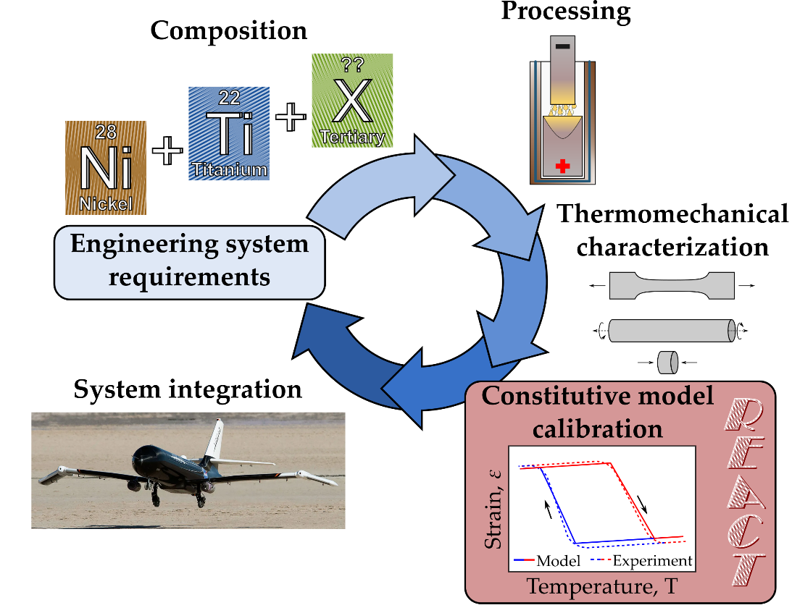

Figure 1: The typical SMA development process involves many discrete steps. This work provides an easy constitutive model calibration tool, the Rendering of Experimental Analysis and Calibration Tool, to enable SMA component design.

For proper/rigorous system design, a material model must capture the full thermomechanical constitutive response (i.e., the relationship between temperature, stress, and strain). The design team calibrates a constitutive model (examples of which include the Brinson and Lagoudas models) to best fit the thermomechanical characterization data in the operating regime of interest. With a calibrated constitutive model, engineers can design the system, considering the intricacies of the SMA in question (variable actuation strain with respect to stress, etc.).

Each stage of the development process detailed above requires significant time and effort, but the greater SMA community has developed tools to speed certain development stages. The composition-processing-property space for SMAs is becoming well understood, and many recently developed tools enable quick discovery of new alloys [1], [2], [3]. ASMADA, the Automatic Shape Memory Alloy Data Analyzer, identifies heating and cooling cycles of SMAs and extracts SMA material properties according to ASTM standard E097 [4], [5], [6]. The Shape Memory Materials Analysis and Research Tool (SM2ART), also known as SMAnalytics, provides an extensive open-source database of tested shape memory alloys and their standard properties [7], [8]. Many research groups have published user material models (i.e., UMATs) to interface with open-source and commercial finite element solvers [9], [10], [11], [12].

However, while commercial software suites enabling superelastic calibration (add Abaqus citation here) and many published methods covering SMA actuator calibration, no such analog exists for SMA actuation models [13], [14], [15]. When considering SMA actuation behavior, a laborious workflow of experimental analysis and constitutive model calibration is still required for rigorous characterization. This is especially difficult for newcomers to the field or those engaged in multi-disciplinary efforts. The various external state variables that govern shape memory material behavior often require synchronization of various datasets from different instruments, slowing the SMA development process. Further, after compiling and synchronizing the data, there exist myriad methods of calibrating an accurate constitutive model to describe the specific SMA material behavior.

In this work, we detail a streamlined open-source tool to help both material scientists and design engineers analyze their thermomechanical data and calibrate an appropriate SMA constitutive model. We deem this tool REACT, for the Rendering of Experimental Analysis and Calibration Tool. REACT provides an intuitive workflow that imports and processes raw unfiltered shape memory alloy mechanical (tensile/compression), thermal (DSC), or thermomechanical (tensile/compression with environmental chamber) data to produce customizable figures and systematically derived material data (depicted schematically in Figure 2). The tool comprises two graphical user interfaces (GUIs), written in python and available on GitHub under the GNU General Public License. These two GUIs accomplish separate essential tasks in the SMA development process: data processing and constitutive model calibration.

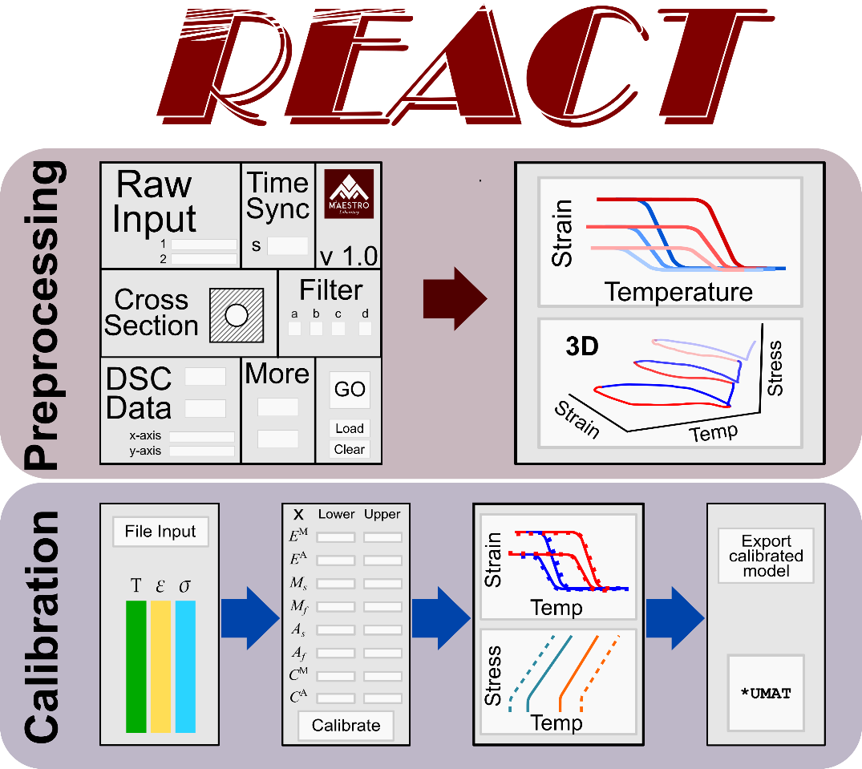

Figure 2: SMA-REACT allows the user to load their own data, specify known model parameters, and find an optimal calibration that best approximates experimental response.

The pre-processing GUI extracts data from multiple inputs such as tensile test data and external thermocouples and automatically synchronize them onto the same time series. With raw force and displacement data, REACT can calculate strains and stresses based on various sample geometries. Coupling temperature, stress, and strain data, this tool can apply customizable filters and remove systematic errors within the dataset, periodically prompting the user for filter approval. The program then produces various figures to help visualize the complex shape memory alloy material behavior.

Given filtered and synchronized experimental data, the calibration GUI finds the best fit of constitutive model parameters (martensitic elastic modulus, austenite start temperature, etc.). Following the thermodynamically consistent model derived by Lagoudas et al., the developed calibration routine leverages global optimization strategies to minimize error between model prediction and experimental data. While many analogous methods exist in literature [15], [16], [17], [18], [19], no such open-source resource exists for the greater community. REACT enables the user to customize the optimization routine as well as the model parameters to be optimized (e.g., bounds and free variables). Outputs from the calibration routine include a set of model parameters to be used in future analyses (i.e., material properties for FEA) and a thermodynamically consistent phase diagram based on calibrated model parameters. We focus on the temperature-driven Lagoudas 1-D constitutive model, but one could leverage the developed framework and extend the software to consider other constitutive models, higher dimensional models (e.g., 3D models with anisotropic effects), and different loading modes (e.g., superelasticity).

**Method description**

**Data-preprocessing**

**Model calibration**

Constitutive model calibration is a vital link for validating SMA behavior and designing to exploit SMA performance. The inherent complexity of SMAs is an opportunity for more space- and weight-efficient assemblies, but a challenge from a design perspective. For many applications, selecting a particular SMA component based on transformation temperature and maximum transformation strain is insufficient; the transformation temperatures and actuation strain in the *operating stress regime* must be well characterized and predictable. Due to the inherent nonlinear thermomechanical coupling present in SMAs, an appropriately calibrated constitutive model is essential for system design.

Historically, SMA model calibration has been performed analytically, based on analyst intuition, and via numerical optimization. Closed-form analytical results/expressions can be derived for simple models when a deterministic amount of data is available [13], [14]. However, when the operating range of the SMA spans many stress regions and requires many (>3) experimental tests, these analytical methods become overdetermined. More recently, many groups have adopted numerical optimization to find the combination of model parameters that best fit experimental data [15], [16], [19], [20]. These approaches help to speed the process, but exist as purpose-built codes and are have limited applicability outside the authors’ specific application or research group.

For this work, due to the inherent interdependence of so many material properties, and assuming that the driving factor for calibration is proper fit of experimental data, we can approach the calibration problem as a numerical optimization problem. For constant force thermal cycle experiments, strain is measured as a function of temperature at certain stress levels. We seek a set of material properties such that the calibrated constitutive model best matches the experimental data over this set of experiments.

Because of the aforementioned material property interdependence, we use a hybrid optimization scheme. Hybrid optimization comprises two stages: global optimization followed by a local search on the best set of design variables that the global optimization found. The global optimization searches the entire space and provides a starting point for a local gradient-based optimization to find the mathematically optimum solution.

Our tool leverages the genetic algorithm NSGA-II [21], [22] for the global search and then SLSQP implemented in SciPy [23] for the local search, although the tool is modular and other optimization algorithms can be inserted in lieu of the ones discussed herein. For all examples we discuss, the we specify the population size and number of generations to be 100 and at least 10, respectively for NSGA-II. SLSQP is constrained to 100 maximum iterations. All relevant optimization parameters are modifiable in the GUI.

**One-dimensional Lagoudas SMA Constitutive Model**

The Lagoudas shape memory alloy constitutive model uses the Gibbs' free energy to derive a thermodynamically consistent relationship between stress and strain. In this work, we will discuss the commonly used temperature- and strain-driven implementation of this model for wider applicability in standard finite element suites. From the perspective of model calibration, seventeen unique but dependent model parameters must be found to best match experimental data. In this section, we will omit a full model derivation, but rather discuss the mathematical foundation of the model and then highlight the seventeen model parameters that need calibrated and their effects on constitutive behavior.

Table 1:The one-dimensional reduction of the Lagoudas SMA constitutive model requires calibration of 17 unique but dependent parameters.

|  |  |  |
| --- | --- | --- |
| **Parameter** | **Mathematical Symbol** | **Units (SI)** |
| **Thermoelastic properties** |  |  |
| Elastic moduli |  | Pa |
| Coefficient of thermal expansion |  | 1/K |
| **Transformation properties** |  |  |
| Transformation temperatures |  | K |
| Stress-influence coefficients |  | Pa/K |
| **Transformation strain properties** |  |  |
| Minimum transformation strain |  | mm/mm |
| Maximum transformation strain |  | mm/mm |
| Critical stress at which transformation strain manifests |  | Pa |
| Transformation strain rise time |  | 1/Pa |
| **Smooth hardening properties** |  |  |
| Smooth hardening coefficients |  | - |

Alternatively, we can discuss the model from the lens of how the calibrated parameters affect constitutive response. We can describe these relationships via three figures:

1. The phase diagram (Figure 3a), which describes the surfaces that define forward and reverse transformation in stress-temperature space. Zero-stress transformation temperatures can be found by inspection, and the stress-influence coefficients are defined as the slopes of the forward and reverse transformation surfaces at the *calibration stress*. The calibration stress is *a priori* defined by the designer, and common practice dictates selecting a value close to the design working stress of the material. Get a citation on this. Talk to Hartl?
2. Constant-force thermal cycles (Figure 3b), which describe material behavior in strain-temperature space and inform designers of actuator-like behavior. The elastic moduli, transformation strain properties, and thermal expansion coefficient can be extracted from this data. Additionally, this plot can give intuition about the smooth hardening coefficients. Note that the transformation strain properties are not simply the strain in martensite minus the strain in austenite; this is a measure of total strain, and the transformation strain must be calculated by applying Hooke's law.
3. The current transformation strain as a function of applied stress (Figure BLANK), which is crucial to understand if the given material exhibits sufficient transformation strain at the design stress. We show a special case herein, where and are both nonzero. However, in most cases, one or both of these material properties are zero. The exponential coefficient k denotes the ``rise time'' or how quickly the transformation strain increases from to . Cite some old work that backs this up. Book? My papers? Bertagne? Leal?

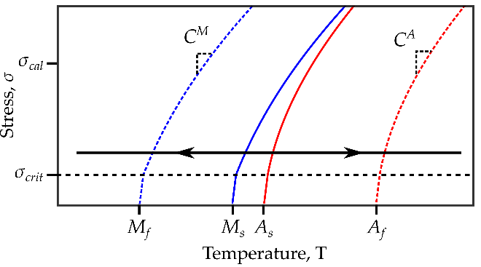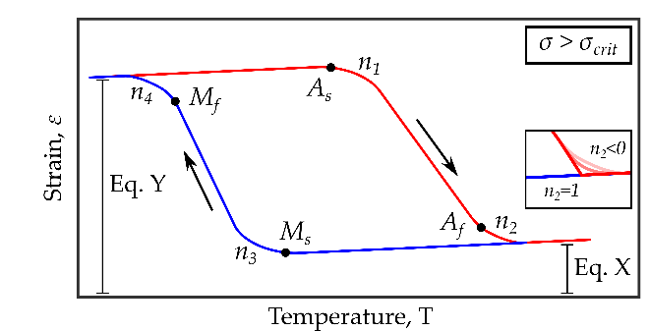

Figure 3: Due to the interdependence of model parameters, numerical optimization is required for a robust fit of experimental data.

As mentioned earlier, the seventeen material properties that define shape memory alloy constitutive response are unique but interdependent. For example, a change in smooth hardening coefficient will cause a change in the corresponding zero-stress transformation temperature. Herein lies a crucial nuance of calibrating the Lagoudas constitutive model: the model defines the transformation temperatures as the point at which transformation begins (i.e., the state where the transformation criteria are activated), rather than the tangent (which is the definition used in ASTM E3097). In past work, manually updating smooth hardness coefficients, transformation temperatures, and stress-influence temperatures to best fit experimental data has been the most time-intensive part of calibration.

Many other material properties are interdependent; a change in transformation strain properties will be reflected in both the strain-temperature response and the shape of the transformation surfaces. Additionally, while the stress-influence coefficients are single numbers for each phase, they are only one part of the mathematical expression to define the transformation surface in stress-temperature space. For these reasons, calibration must leverage numerical optimization to ensure a robust fit of experimental data.

**Calibration via numerical optimization**

The current implementation of the tool, in a GUI-based format, allows the SMA designer to specify both optimization parameters and material property bounds and values. If the SMA designer has prior knowledge of certain properties (e.g., Young’s moduli from tensile tests), they can define these properties and the optimization will minimize error between model prediction and experiment by varying all other material properties. In this way, our GUI allows the designer greater flexibility than previous methods, but the typical iterative method can still be used. The only difference is the speed in which different combinations of material properties and their respective bounds can be tested.

Depending on the size of the optimization, each calibration routine can execute in less than 10 minutes, and those who are not innately familiar with the Lagoudas SMA constitutive model can easily digest the results. In this way, our tool provides a high-throughput, low-barrier-to-entry calibration method that we hope to increase use of SMAs in practice.

**Post-processing and outputs**

**Implementation example**

**Experimental data**

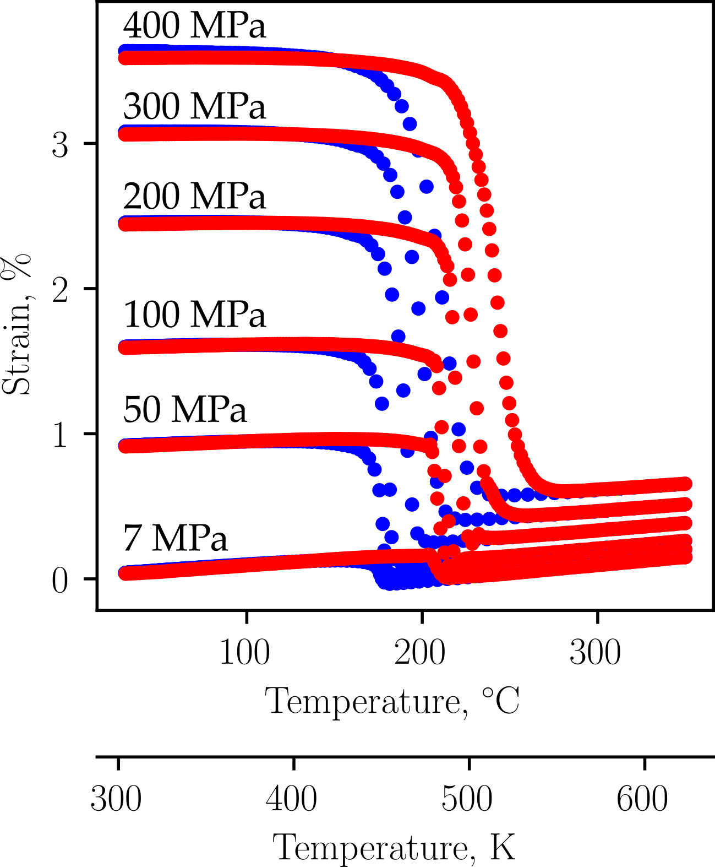

Figure 4: To demonstrate the utility of SMA-REACT, we will calibrate a constitutive model to fit published experimental data [24].

To calibrate an accurate SMA constitutive model to capture actuator behavior, *n* isobaric (constant force thermal cycling) tests, where *n* is preferably greater than 4, are required. Each test requires stress-strain-temperature histories.

We use experimental data of a Ni50.5Ti27.2Hf22.3 alloy from Bigelow et al [24]. NiTiHf is a relevant material system, with many members of the SMA community exploring Hf additions for high-temperature performance [24], [25], [26]. Additionally, the quality and quantity of data (i.e., six different constant force thermal cycles), non-zero coefficients of thermal expansion, and nonlinear relationship between applied stress and transformation strain make this data set an ideal candidate to demonstrate the utility of our calibration tool.

**Conventional calibration procedure**

The 17 unknown parameters that define the Lagoudas SMA constitutive model can be calibrated without a global optimization strategy by estimating parameter groups (e.g., transformation temperatures, thermoelastic properties, etc.) sequentially. However, due to the nonlinearities present in the model with respect to the current transformation strain (H_cur) and smooth hardening coefficients (n_i), optimization, or nonlinear curve fitting, is still required. We will discuss one method to find these parameters without using a global optimization strategy, as this method can serve as a good baseline with which to compare the optimized calibration.

|  |  |
| --- | --- |
| a) Constant-stress force cycling data for five distinct stress levels. | b) Zero-stress transformation temperatures and stress-influence coefficients at the calibration stress can be extracted directly from CFTC data. |
| c) Austenite elastic modulus can be found via Hooke's law at the reference temperature, which is a model parameter defined by the analyst. | d) Nonlinear curve fitting is necessary to find transformation strain properties, Marteniste elastic modulus, and coefficient of thermal expansion. |

*Figure 5: Given constant-stress thermal cycling (CFTC) data for several stress levels, the Lagoudas SMA constitutive model can be calibrated using local curve-fitting routines. However, this method still relies on many manual iterations to find smooth hardening coefficients (not shown above). In each subfigure above, the parameters found are displayed in the grey box in the lower-right corner.*

First, transformation temperatures for each tested stress level can be estimated via the tangent method or similar. If a “zero-stress” isobaric test (i.e., 7 MPa or lower) was performed, the transformation temperatures found for this test can be taken as the zero-stress transformation temperatures etc. Otherwise, each zero-stress transformation temperature can be found via the x-intercept of a linear regression of the transformation temperatures as a function of stress. This estimate is equivalent to a Lagoudas model calibration with smooth hardening parameters set to . The average slope of the start and finish transformation surfaces for martensite and austenite for a specified stress range about the user-determined *calibration stress* can be taken as the stress-influence coefficients ( and ). Note that the stress-influence coefficients should not be derived from the average slope from estimated transformation temperatures at all stress levels; most shape memory alloys exhibit a nonlinear change in transformation temperature with respect to stress (see Figure 3(b) in [24]), and the Lagoudas model compensates for this via the transformation surfaces (), where the stress-influence coefficients at the calibration stress are a contributing factor.

With transformation temperatures and stress-influence coefficients estimated, thermoelastic properties and transformation strain properties can be calculated. Austenite elastic modulus can be found by extracting the total strains and a temperature well above at each tested stress level. Then, by designating this temperature such that , Hooke’s law becomes:

Austenite elastic modulus is the best-fit linear coefficient from this equation.

At this point, the analyst has two choices in terms of calculating the rest of the thermoelastic and transformation strain properties. First, the coefficient of thermal expansion can be calculated separately by extracting the total strain at another temperature :

Alternatively, coefficient of thermal expansion can be found concurrently with the other thermoelastic and transformation strain properties via a nonlinear system of equations. At a temperature , Hooke’s Law can be written as:

where

In this equation, there are six unknowns: and . Ideally, to calibrate these six unknowns, one will have performed six or more constant-force thermal cycle tests. However, for shape memory materials that do not exhibit two-way shape memory effect, both and can be set to zero, reducing the number of required tests to four. If the coefficient of thermal expansion was calibrated based on elastic response, the other five parameters are calibrated in the same way as described above.

Both of these approaches to calculate the remaining thermoelastic properties and transformation strain properties may introduce modeling errors. TIf , the strain due to thermal expansion will be incorrectly predicted across the tested temperature range. However, this is a limitation of the one-dimensional reduction of the Lagoudas constitutive model; assuming thermal expansion is invariant of material phase allows for the use of simpler nonlinear solution methods (i.e., Convex Cutting Plane). Additionally,

At this point, all material properties are estimated; to fully capture the true strain-temperature response, iterative calibration of each smooth hardening coefficient is necessary until a satisfactory fit is accomplished. Due to the interdependencies highlighted earlier, each change of smooth hardening coefficient will need to be accompanied by a change in the associated transformation temperature and perhaps stress-influence coefficient (i.e., a change in will need to be accompanied by a change in and ). Without global numerical optimization, the best model calibration will be found via manual changes and the analyst’s intuition.

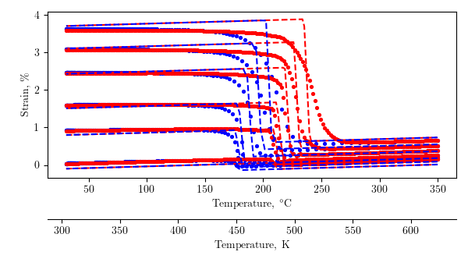

Figure 9: Conventional analytical/numerical calibration techniques produce a passable solution, but rely on user iterations to fine-tune model response.

The resulting conventional calibration, with , is shown in Figure 5. The mean squared error between model and experiment is 3.13% (see equation BLANK), which for many applications could suffice. Transformation temperatures and transformation strain properties are well-captured, as the model bisects the experimental curves as a function of stress (i.e., the martensite elastic response is underpredicted at low levels of applied stress but over approximated at high levels of applied stress). However, there are several areas that could be improved. The coefficient of thermal expansion is too high, as shown by the large deviance between model and experiment in Martensite, especially immediately before forward transformation. Additionally, this calibration routine still requires a nonlinear curve fitting procedure to find the transformation strain properties, as well as requiring more intuition about the relationship between model parameters and constitutive response.

**Calibration via numerical optimization**

The conventional calibration shown above is used as a starting point for a global numerical calibration using SMA-REACT. Because the current optimization strategy includes a preliminary genetic algorithm followed by a gradient-based algorithm, the previously found model parameters were used to determine bounds for each model parameter (i.e., the conventional calibration estimated austenitic elastic modulus as BLANK, so the bounds were set to BLANK and BLANK). This allows the optimizer to start in the neighborhood of feasible solutions, but gives it freedom to explore for a better performing result.

Then, based on the values to which the optimization converged, the parameters that converged to the bounds were further inspected, bounds were widened, further improving the calibration accuracy. This process of inspecting the converged results and comparing to the optimization bounds was repeated three times until each parameter converged to a value well within the set bounds. This indicates that a local optimum is found, and with a large enough initial population in the genetic algorithm, we are confident that this is near the globally optimal calibration for this model formulation.

Table 2: The SMA-REACT tool allows further refinement of the calibrated solution.

|  |  |  |
| --- | --- | --- |
| **Calibration Number** | **Mean squared error** | **Notes** |
| 1 | 3.13% | Analytical calibration, . |
| 2 | 2.09% | Numerical calibration with bounds around analytical values |
| 3 | 1.57% | Widened bounds on and . |
| 4 | 1.46% | Widened bounds on and . Fixed and . |
| 5 | 1.43% | Widened bounds on . Fixed everything but transformation temperatures and . |

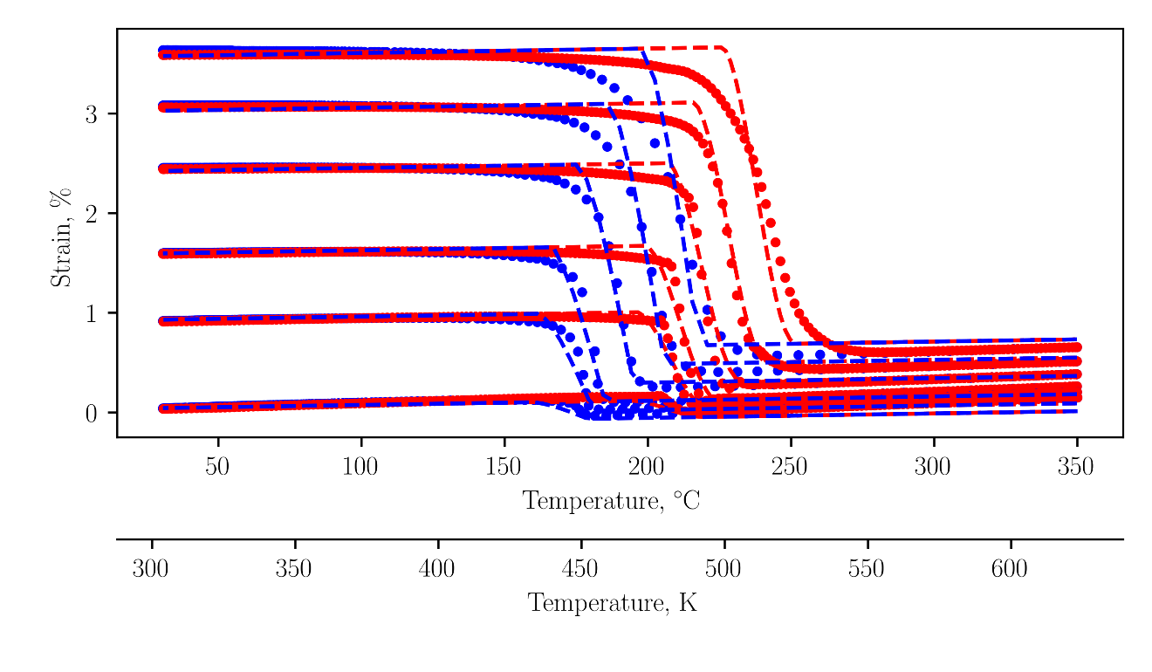

Figure 10: The final calibration agrees with the experimental data to within 1.5% mean squared error.

The final numerical calibration is depicted in Figure 6. The model predicts the elastic response in martensite almost perfectly, which signifies that both the martensitic elastic modulus and transformation strain properties are well calibrated. Transformation temperatures show good agreement at low levels of applied stress. At higher levels of applied stress, the model-predicted transformation overshoots the experimental data and predicts a smaller hysteresis. This is because the transformation temperatures are not a linear function of stress (i.e., the stress-influence coefficients are not constant, see figure BLANK in Bigelow (cite)), and because the smoothness of transformation initiation is not constant with stress (compare the 100 MPa transformation into austenite with the analogous location at 300 MPa). This calibration is a perfect example of the utility of numerical optimization; the optimizer finds the best global fit of data, especially regarding the austenite transformation temperatures. For lower stresses, is too low, and is too high. At intermediate stresses, like 100 and 200 MPa, the transformation temperatures are almost perfect. Then, at 300 MPa, is too late and is too early. This could be better fit at the relevant stresses by biasing the solution to prioritize fitting certain stress levels (see my paper) or by simply calibrating the model at the stress levels that matter most.

However, this calibration is not perfect, mainly due to model deficiencies. The coefficient of thermal expansion is not constant for austenite and martensite. Clearly, the coefficient of thermal expansion in austenite is larger than that in martensite. This is a model deficiency because the current model uses a convex cutting plane assumption for numerical integration and could be improved in future work.

Regardless, these five optimizations improved calibration accuracy by over 50% compared to the conventional calibration, and were accomplished in less than an hour on a lightweight laptop with a low-performance processor (Intel Core m3-6Y30 CPU @ 0.90 GHz with 4 Gb RAM). Herein lies the chief contribution of this work: this calibration routine can be performed by general analysts, designers, or material scientists, without the need for exotic hardware or python programming experience.

**Conclusions and further refinements**

SMA-REACT is an open-source, easy-to-use tool for characterization data post-processing and shape memory alloy constitutive model calibration. While we have focused on the Lagoudas constitutive model and actuator (i.e., constant force thermal cycling) behavior, the tool is easily extensible to other constitutive models or loading modes. By framing the calibration routine as a numerical optimization problem, SMA-REACT can find robust calibrations that outperform conventional (i.e., by hand) calibrations by 50% or more, without requiring detailed knowledge of programming, optimization, or the Lagoudas constitutive model. This allows the tool to be approachable for a wide range of students and professionals working on shape memory alloys. The speed at which model calibrations can be fine-tuned allows for rapid iterations to converge to a satisfactory model calibration, which can then be used in commercial finite element suites like ABAQUS.

We distribute the SMA-REACT toolset and source code under the GNU General Public License, which allows anyone to run, study, share, and modify the code. We invite any modifications that users may find useful, including, but not limited to, alternative loading modes (i.e., superelasticity or combined superelasticity/shape memory [17]), alternative constitutive models [27], [28], [29], [30], or any usability enhancements for more robust data import or export. In particular, we believe seamless integration with NASA tools such as the Shape Memory Materials Database would be very enabling to the greater SMA community [7]. SMA-REACT aims to reduce the barrier between materials scientists and engineers, and will hopefully enable more widespread adoption of shape memory alloys in engineering applications.

**Bibliography**

[1] W. Trehern, R. Ortiz-Ayala, K. C. Atli, R. Arroyave, and I. Karaman, “Data-driven shape memory alloy discovery using Artificial Intelligence Materials Selection (AIMS) framework,” *Acta Mater.*, vol. 228, p. 117751, Apr. 2022, doi: 10.1016/j.actamat.2022.117751.

[2] A. Demblon, J. H. Mabe, and I. Karaman, “Compositional effects on strain-controlled actuation fatigue of NiTiHf high temperature shape memory alloys,” *Scr. Mater.*, vol. 242, p. 115904, Mar. 2024, doi: 10.1016/j.scriptamat.2023.115904.

[3] S. J. Honrao, O. Benafan, and J. W. Lawson, “Data-Driven Study of Shape Memory Behavior of Multi-Component Ni–Ti Alloys in Large Compositional and Processing Space,” *Shape Mem. Superelasticity*, vol. 9, no. 1, pp. 144–155, Mar. 2023, doi: 10.1007/s40830-022-00405-x.

[4] M. C. Kuner, A. A. Karakalas, and D. C. Lagoudas, “ASMADA—A tool for automatic analysis of shape memory alloy thermal cycling data under constant stress,” *Smart Mater. Struct.*, vol. 30, no. 12, p. 125003, 2021.

[5] ASTM, “Standard test method for mechanical uniaxial constant force thermal cycling of shape memory alloys,” ASTM International, West Conshohocken, PA, E3097-17, 2017. [Online]. Available: https://www.astm.org/e3097-17.html

[6] D. E. Nicholson *et al.*, “Standardization of Shape Memory Alloys from Material to Actuator,” *Shape Mem. Superelasticity*, vol. 9, no. 2, pp. 353–363, Jun. 2023, doi: 10.1007/s40830-023-00431-3.

[7] O. Benafan, G. S. Bigelow, and A. W. Young, “Shape Memory Materials Database Tool—A Compendium of Functional Data for Shape Memory Materials,” *Adv. Eng. Mater.*, vol. 22, no. 7, p. 1901370, 2020, doi: 10.1002/adem.201901370.

[8] P. E. Caltagirone and O. Benafan, “Shape Memory Materials Analysis and Research Tool (SM2ART): Finding Data Anomalies and Trends,” *Shape Mem. Superelasticity*, Jul. 2023, doi: 10.1007/s40830-023-00457-7.

[9] D. Hartl and D. C. Lagoudas, “Characterization and 3–D Modeling of Ni60Ti SMA for Actuation of a Variable Geometry Jet Engine Chevron,” in *Proceedings of SPIE, Smart Structures and Materials*, San Diego, CA, Mar. 2007, pp. 1–12.

[10] L. Xu, T. Baxevanis, and D. C. Lagoudas, “A three-dimensional constitutive model for the martensitic transformation in polycrystalline shape memory alloys under large deformation,” *Smart Mater. Struct.*, vol. 28, no. 7, p. 074004, Jun. 2019, doi: 10.1088/1361-665X/ab1acb.

[11] L. Xu, A. Solomou, T. Baxevanis, and D. Lagoudas, “Finite strain constitutive modeling for shape memory alloys considering transformation-induced plasticity and two-way shape memory effect,” *Int. J. Solids Struct.*, vol. 221, pp. 42–59, Jun. 2021, doi: 10.1016/j.ijsolstr.2020.03.009.

[12] G. Scalet, F. Niccoli, C. Garion, P. Chiggiato, C. Maletta, and F. Auricchio, “A three-dimensional phenomenological model for shape memory alloys including two-way shape memory effect and plasticity,” *Mech. Mater.*, vol. 136, p. 103085, Sep. 2019, doi: 10.1016/j.mechmat.2019.103085.

[13] F. Auricchio, A. Coda, A. Reali, and M. Urbano, “SMA Numerical Modeling Versus Experimental Results: Parameter Identification and Model Prediction Capabilities,” *J. Mater. Eng. Perform.*, vol. 18, no. 5, pp. 649–654, Aug. 2009, doi: 10.1007/s11665-009-9409-7.

[14] D. J. Hartl and D. C. Lagoudas, “Thermomechanical Characterization of Shape Memory Alloy Materials,” in *Shape Memory Alloys: Modeling and Engineering Applications*, D. C. Lagoudas, Ed., New York: Springer-Verlag, 2008.

[15] D. Whitten and D. Hartl, “Iterative calibration of a shape memory alloy constitutive model from 1D and 2D data using optimization methods,” in *Behavior and Mechanics of Multifunctional Materials and Composites 2014*, SPIE, 2014, pp. 21–31.

[16] P. B. C. Leal and M. A. Savi, “Shape memory alloy-based mechanism for aeronautical application: Theory, optimization and experiment,” *Aerosp. Sci. Technol.*, vol. 76, pp. 155–163, May 2018, doi: 10.1016/j.ast.2018.02.010.

[17] P. B. C. Leal, M. Cabral-Seanez, V. B. Baliga, D. L. Altshuler, and D. J. Hartl, “Phase transformation-driven artificial muscle mimics the multifunctionality of avian wing muscle,” *J. R. Soc. Interface*, vol. 18, no. 184, p. 20201042, Nov. 2021, doi: 10.1098/rsif.2020.1042.

[18] C. Bertagne, P. Walgren, L. Erickson, R. Sheth, J. Whitcomb, and D. J. Hartl, “Coupled Behavior of Shape Memory Alloy-Based Morphing Spacecraft Radiators: Experimental Assessment and Analysis,” *Smart Mater. Struct.*, Apr. 2018, doi: 10.1088/1361-665X/aabbe8.

[19] P. Walgren, S. Nevin, and D. Hartl, “Design, experimental demonstration, and validation of a composite morphing space radiator,” *J. Compos. Mater.*, p. 00219983221144499, Dec. 2022, doi: 10.1177/00219983221144499.

[20] P. Walgren *et al.*, “Development and Testing of a Shape Memory Alloy-Driven Composite Morphing Radiator,” *Shape Mem. Superelasticity*, pp. 1–10, Jan. 2018, doi: 10.1007/s40830-018-0147-2.

[21] K. Deb, A. Pratap, S. Agarwal, and T. Meyarivan, “A fast and elitist multiobjective genetic algorithm: NSGA-II,” *IEEE Trans. Evol. Comput.*, vol. 6, no. 2, pp. 182–197, 2002.

[22] F.-A. Fortin, F.-M. D. Rainville, M.-A. Gardner, M. Parizeau, and C. Gagné, “DEAP: Evolutionary Algorithms Made Easy,” *J. Mach. Learn. Res.*, vol. 13, pp. 2171–2175, Jul. 2012.

[23] P. Virtanen *et al.*, “SciPy 1.0: fundamental algorithms for scientific computing in Python,” *Nat. Methods*, vol. 17, no. 3, pp. 261–272, Mar. 2020, doi: 10.1038/s41592-019-0686-2.

[24] G. S. Bigelow, A. Garg, O. Benafan, R. D. Noebe, S. A. Padula, and D. J. Gaydosh, “Development and testing of a Ni50.5Ti27.2Hf22.3 high temperature shape memory alloy,” *Materialia*, vol. 21, p. 101297, Mar. 2022, doi: 10.1016/j.mtla.2021.101297.

[25] O. Benafan, G. S. Bigelow, A. Garg, R. D. Noebe, D. J. Gaydosh, and R. B. Rogers, “Processing and Scalability of NiTiHf High-Temperature Shape Memory Alloys,” *Shape Mem. Superelasticity*, vol. 7, no. 1, pp. 109–165, Mar. 2021, doi: 10.1007/s40830-020-00306-x.

[26] B. Kockar, I. Karaman, J. I. Kim, and Y. Chumlyakov, “A method to enhance cyclic reversibility of NiTiHf high temperature shape memory alloys,” *Acta Mater.*, vol. 54, no. 12, pp. 2203–2208, 2006.

[27] L. C. Brinson, “One-Dimensional Constitutive Behavior of Shape Memory Alloys: Thermomechanical Derivation with Non-Constant Material Functions and Redefined Martensite Internal Variable,” *J. Intell. Mater. Syst. Struct.*, vol. 4, pp. 229–242, 1993.

[28] L. C. Brinson and M. S. Huang, “Simplifications and Comparisons of Shape Memory Alloy Constitutive Models,” *J. Intell. Mater. Syst. Struct.*, vol. 7, pp. 108–114, 1996.

[29] F. Auricchio, R. L. Taylor, and J. Lubliner, “Shape-Memory Alloys: Macromodelling and Numerical Simulations of the Superelastic Behavior,” *Comput. Methods Appl. Mech. Eng.*, vol. 146, pp. 281–312, 1997.

[30] F. Auricchio and E. Sacco, “A One-Dimensional Model for Superleastic Shape-Memory Alloys With Different Elastic Properties Between Austenite and Martensite,” *Int. J. Non-Linear Mech.*, vol. 32, no. 6, pp. 1101–1114, 1997.